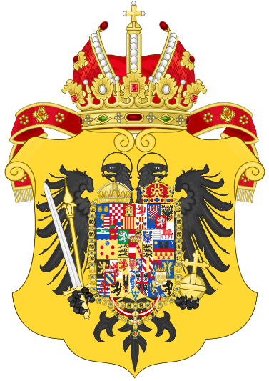
The Salien Family (HRE)
Conrad III – Gisela
(1024-1039)

Agnes – Henry III – Gunhilda
(1039-1056)

Bertha – Henry IV – Eupraxia
(1056-1105)

Matilda -Henry V Agnes – Frederick I of Hohenstaufen The Supplinburg
(1106-1125) Family (HRE)

Lothar (1125-1137)

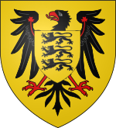
The Hohenstaufen Family (HRE)
Agnes -- Frederick I

Judith – Frederick II Conrad III
(1138-1152)
Frederick I Barbarossa – Adelheid – Beatrice
(1152-1190)

Phillip (assassinated Constance – Henry VI Wolf Family
(1197-1200) at wedding) (1190-1197) Otto IV
(1201-1218)

