What Naomi Wolf and Cokie Roberts teach us about the need for historians

Without historical training, it’s easy to make big mistakes about the past.
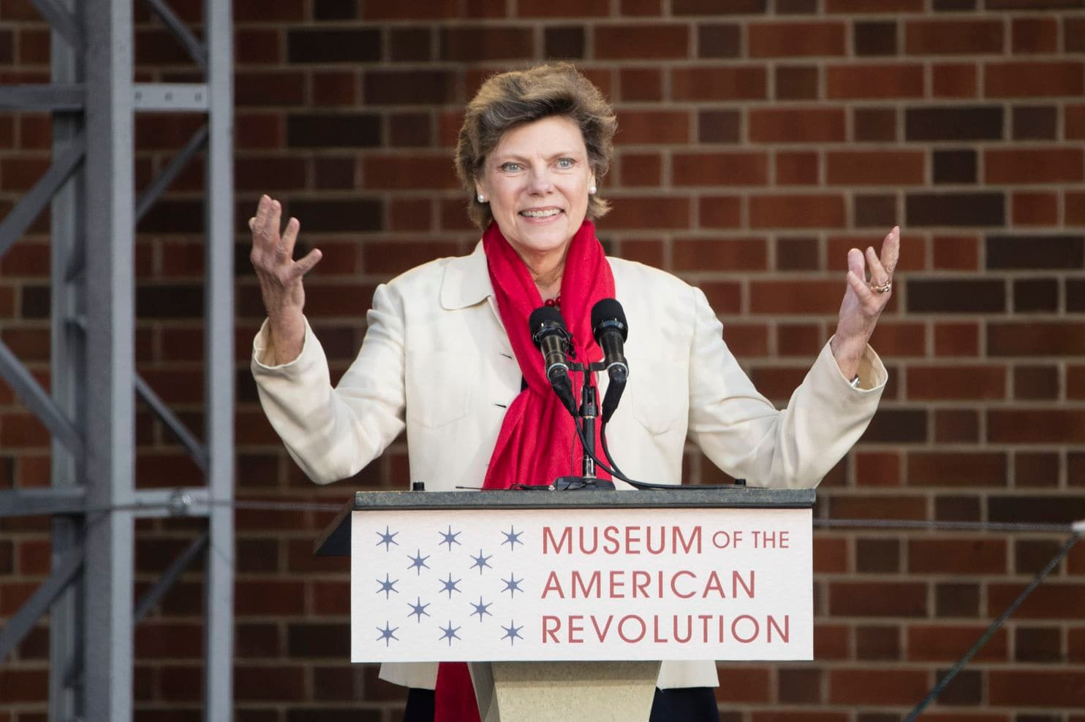
Cokie Roberts spoke the opening ceremony for Museum of the American Revolution in Philadelphia last year. (Matt Rourke)

By Karin Wulf
Karin Wulf is executive director of the Omohundro Institute of Early American History & Culture, and professor of history at William & Mary. She is also a co-founder of Women Also Know History.
June 11
It’s been a tough few weeks for amateur history. First, journalist Naomi Wolf discovered on live radio that she had misinterpreted key historical terms in her new book, “Outrage,” leading her to draw the wrong conclusions. A week later, journalist Cokie Roberts, too, got a quick smackdown when she claimed on NPR that she couldn’t find any incidence of abortion advertised in 19th century newspapers, a claim quickly disproved by historians.
Wolf and Roberts fell victim to a myth widely shared with the American public: that anyone can do history. Whether it’s diving into genealogy or digging thorough the vast troves of digital archives now online, the public has an easy way into the world of the past. And why would they imagine it takes any special training? After all, the best-selling history books are almost always written by non-historians, from conservative commentators like Bill O’Reilly to journalists like Wolf and Roberts.
But like medicine, law or engineering, history is a profession for which scholars spend years learning crucial skills and absorbing bodies of work that help them to interpret the past. While we can and must encourage more people to dig into our past and work to better understand it, we also must understand how critical the specialized toolbox of historians is to getting the past right.
The Roberts incident highlights the limits of casual inquiries into the past. Last week, when she was asked about the history of abortion in the United States during an interview on NPR’s “Morning Edition,” she claimed that, in a search of 19th-century newspapers, she never found an incidence of abortion advertised. That led her to conclude that historians who had written about the frequency of abortions during this period were distorting history, driven by their own political views.
Almost immediately scholars began responding on social media, pointing out grave errors of fact and context in Roberts’s interpretation. A tweet thread by historian Lauren MacIvor Thompson, with specific examples from newspapers, was “liked” and shared thousands of times within hours.
In reality, there were plenty of advertisements in those newspapers for abortion services — they just used language that must have been unfamiliar to Roberts. For centuries women had been seeking out methods to “unblock menses” or other such descriptions for abortifacients. The women of the era may not have had the same language or understanding of the physiology of reproduction that we do today, but they did want to control reproduction and sought out the means to do so.
Roberts’s flub echoed Wolf’s blunder in misinterpreting a key term from Victorian England. Wolf assumed that “death recorded” signified an execution, when in reality, it meant the exact opposite: “Death recorded” was a term that allowed judges to abstain from handing down a death sentence.
These mistakes are not just the fault of Roberts and Wolf. Rather, they reflect a system in which we ask journalists — and historians, too — to stretch themselves to become generalists, a system that prizes entertainment over substance and more to the point, dilutes the key contributions of historical training.
The sense that anyone can do history reflects the field’s double-sided accessibility problem. History is of such wide and compelling interest that we see it communicated all around us through school curriculums, museums and all sorts of media forms, from television and movies to blogs and podcasts. But the main criteria for some platforms is often the ability to communicate well, not specialized training in historical research.
Historians have also actively included the public in historical research, ranging from soliciting volunteer transcription teams for big archival projects to embracing contributions from citizen historians, whether through vital advocacy for forgotten or ignored histories of all kinds, through family history websites or via local history projects.
Yet the ability of just about anyone to produce a historical podcast or to jump into a historical project can make it seem that anyone with enough enthusiasm can do historical scholarship — leaving us unclear about where expertise comes in. Joanne Freeman, Yale historian and premiere expert on Alexander Hamilton, recently narrated via Twitter a series of “conversations with historians” that covered a wide variety of misconceptions about the work that historians do.
These misconceptions include the notion that historians are generalists, and therefore know all history. In reality, historical knowledge is highly specialized. Someone who studies post-World War II America may have little grasp of, for example, medieval Europe. It is significant that the podcast that Freeman co-hosts, “Backstory,” always includes specialists for multiple segments of each episode, despite having a regular team of five historians.
Freeman’s list also included the expectation that historians are detail aggregators who do or should know random details of a specific event from the past. In reality, historians often focus on the big picture, with an eye to the particular details emerging from the record that illuminate what happened, and why. Deep research in the historical record, such as 19th-century newspapers read alongside other materials, crucially shapes how fully we understand the past.
Finally, and most tellingly, Freeman’s conversations tackled the topic of revisionism, or the public perception that any historian who offers new information or a new interpretation is instantly suspect (a common accusation on Twitter).
In reality, historical understanding isn’t static any more than knowledge in any other field. We wouldn’t expect our doctors to convey the same information that our parents received from doctors decades ago. The same holds true for history. New sources — text, objects, images or oral histories — become available all the time, along with new methods and fresh perspectives on the past. Such developments show how powerful forces shape what we know about the past, and why.
It is no coincidence, for example, that it has taken decades of scholarship on the pervasiveness of slavery, as well as decades of attention to racial inequality, for slavery to become one of the key interpretive issues about America’s founding generation. To know that Thomas Jefferson and George Washington enslaved men, women and children does not occlude their role in generating the founding documents and practices of the United States, but must sit beside it and be explained. Pointing this out is not serving an agenda: It is composing a more complete picture.
What historians know about their fields is how to locate and assess this ever-expanding world of historical sources, methods and perspectives for a specific time, place and subject. Historians learn from one another and build on each other’s work to get an ever clearer, fuller picture of the past. And it is often this interplay that non-historians trying to write history miss.
Perhaps Roberts thought she could answer the question about abortion, but her lack of knowledge of either the language of the time or the scholarship on abortion before Roe vs. Wade doomed her to this mistake. Her producers, though, set her up. They may have thought that her own histories for general audiences — based on sources drawn mostly from the letters and diaries of elite, white women in Washington, D.C. — gave her the depth and breadth of historical knowledge that a historian who studies the history of women, gender and medicine would have.
NPR offered a mild corrective to the “Morning Edition” segment, but millions of people had already heard the original. Given the invaluable nature of history, it’s crucial that we get it right. That means publishers and media outlets seeking answers to the history behind the news need to seek out experts to find these answers. Not doing so risks conveying a distorted understanding of history, which will, in turn, shape the present. And as the cases of Jefferson and Washington suggest, once this happens, it’s hard to dislodge. So many historians listen to NPR — it’s time NPR started listening to them.

