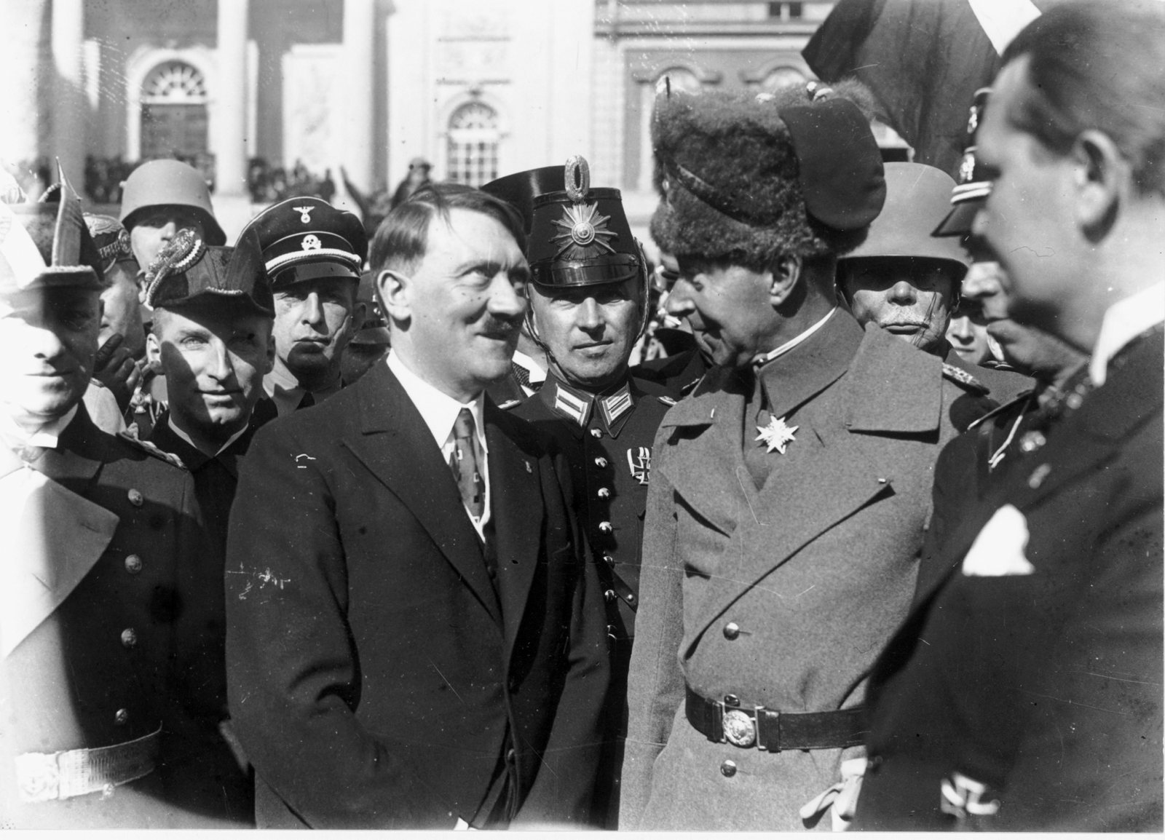

What Do the Hohenzollerns Deserve?
David Motadel
March 26, 2020 Issue

In the early hours of November 10, 1918, Kaiser Wilhelm II, the last German emperor of the Hohenzollern dynasty, fled by train into exile in the Netherlands. The armistice ending World War I was signed the next day. Under the Weimar Constitution of 1919, Germany’s monarchy was abolished; its aristocracy lost its privileges but was allowed to keep much of its property. After World War II, however, the Soviet authorities expropriated the possessions of the former noble families—palaces, manor houses, lands—in their occupation zone of eastern Germany, which was soon to become the German Democratic Republic. Following German reunification in 1990, some of those families sought to reclaim what they had lost. A law passed in 1994 allowed for restitution or compensation claims, though only on condition that the claimants or their ancestors had not “given substantial support” to the National Socialist or East German Communist regimes.
The Hohenzollerns were among those who demanded compensation, as well as the return of tens of thousands of priceless artworks, antiquities, rare books, and furniture now in public museums, galleries, and palaces. Among their requests is the right to reside in one of the Potsdam palaces, preferably the grand 176-room Cecilienhof, which today is a museum. Despite years of negotiations between the German state and the family, their claims remain unresolved. Last summer, as more and more details about the negotiations in the case were leaked to the German press, a bitter public controversy erupted over Germany’s monarchical past. The critical question is whether the Hohenzollerns had “given substantial support” to the Nazi regime.
To be sure, the dynasty’s history is bleak, tainted by colonial massacres, most notably the Herero and Nama genocide in German Southwest Africa in 1904–1908, as well as by its aggressive warmongering in 1914. After World War I, Wilhelm II made no secret of his deep hatred for the Weimar Republic. In 1919, in a letter to one of his former generals, the exiled emperor, whose anti-Semitism grew more and more virulent during the interwar years, blamed the Jews above all for the fall of the monarchy:
The deepest, most disgusting shame ever perpetrated by a people in history, the Germans have done onto themselves. Egged on and misled by the tribe of Juda whom they hated, who were guests among them! That was their thanks! Let no German ever forget this, nor rest until these parasites have been destroyed and exterminated from German soil! This poisonous mushroom on the German oak-tree!
“Jews and mosquitoes,” he wrote in the summer of 1927, were “a nuisance that humanity must get rid of in some way or other,” adding: “I believe the best would be gas!” After the outbreak of World War II, he enthusiastically celebrated the Wehrmacht’s victories in Poland, Scandinavia, Belgium, Holland, and France. Yet during his years of exile the aging monarch, who died in 1941, shortly before Hitler’s invasion of the Soviet Union, had little influence on German politics.
More relevant to a resolution of the family’s claims are the actions of the emperor’s eldest son, the self-proclaimed “crown prince” Wilhelm, who was the most senior member of the dynasty in Germany in the 1920s and 1930s and the owner of the Hohenzollern properties at the time of the Soviet expropriation. The facts, known to historians for decades, seem clear: Wilhelm, who was determined to destroy the hated Weimar Republic, backed its right-wing enemies, believing that this would pave the way for the restoration of the monarchy. And he came out in support of Hitler early. In the second round of the presidential elections in the spring of 1932—after having abandoned the idea of running himself—he endorsed Hitler rather than his opponent, the elderly president and former imperial field marshal Paul von Hindenburg, thereby legitimizing the Nazi movement among conservative and royalist segments of German society. Hitler, reportedly “with a smile,” told the British Daily Express, “I value the ex–Crown Prince’s action highly. It was an absolutely spontaneous action on his part, and by it he has publicly placed himself in line with the main body of patriotic German nationalists.”
Wilhelm also helped the Nazis on other occasions. In 1932, for example, he tried to convince Defense Minister Wilhelm Groener to lift the ban on the Nazi paramilitary groups, the SA and SS. And after Hitler was appointed chancellor on January 30, 1933, Wilhelm wasted no time ingratiating himself with Germany’s new leader. In a stream of letters to Hitler, he professed his unconditional loyalty to the regime. In 1934, for the international press, he proudly posed in front of a mirror at Cecilienhof wearing a swastika armband. Most of the other Hohenzollerns, although far less prominent, behaved similarly. Wilhelm’s younger brother August Wilhelm (“Auwi”), a high-ranking SA leader, was a committed Nazi.
One of Wilhelm’s most important services to the regime was his participation in the Day of Potsdam on March 21, 1933, a spectacle staged by the Nazis to present themselves as the heirs to a glorious Prussian past. Representing the Hohenzollern dynasty, Wilhelm, along with three of his brothers, took part in the carefully choreographed proceedings at Potsdam’s Garrison Church. The highlight of the event was a handshake between President von Hindenburg and Hitler. The Day of Potsdam symbolized the pact between the Nazi movement and the old elites, reassuring the sizable conservative parts of the population. It was the regime’s first major propaganda triumph, and it was enabled by the former royal family and its aristocratic allies.
The Hohenzollerns were by no means unrepresentative. Crucial to Hitler’s ascent to power was a coalition between the Nazis and Germany’s old conservative elites, who hoped they could use and control him for their own ends. It was they who arranged Hitler’s appointment as Reich chancellor, plotted in the backrooms of gentlemen’s clubs, in officers’ messes, and at dinners and shooting parties on grand estates. The German historian Karl Dietrich Bracher demonstrated as early as 1955, in his Die Auflösung der Weimarer Republik, that it was their actions that destroyed Weimar democracy, not an inevitable political crisis. “What is more disturbing to our peace of mind,” Hannah Arendt noted around the same time in The Origins of Totalitarianism, “is the unquestionable attraction these movements exert on the elite, and not only on the mob elements in society.” Hitler’s regime was supported by a broad spectrum of right-wing groups, including the royalist right, that were united in their hatred of liberal democracy, communism, and Jews.
The Nazis were initially eager to get backing from the monarchists. It was only after their consolidation of power that they lost interest in the former royal family. When monarchical organizations were banned in 1934, Wilhelm was forced to realize that Hitler would not help him gain more political influence. Nevertheless, the “crown prince” continued to endorse the regime’s policies. During the war, he sent telegrams to Hitler, addressed as “mein Führer,” to congratulate him on his military victories. Given this historical record, it would seem rather difficult to claim that Wilhelm did not lend the Nazis “significant support.”
Yet the current head of the Hohenzollern family, the forty-three-year-old Georg Friedrich Prinz von Preußen, the great-great-grandson of Wilhelm II, does not seem too concerned about his family’s dark past. To support his claims, he engaged Christopher Clark, Regius Professor of History at the University of Cambridge, to write an expert report on the family’s relationship with the Nazis. Clark is the author of the best-selling Kaiser Wilhelm II (2000), which depicted the emperor more sympathetically than most other major academic biographies; Iron Kingdom: The Rise and Downfall of Prussia, 1600–1947 (2006), which broke with the long-prevailing negative view of Prussia as autocratic and militaristic; and The Sleepwalkers: How Europe Went to War in 1914 (2012), which challenged the view that Germany bore the primary responsibility for the outbreak of World War I. The books have made him a hero to the German conservative right.
In his nineteen-page report, which he wrote in 2011, Clark acknowledges that “Crown Prince” Wilhelm, “a man on the right fringes of the political spectrum,” showed support for Hitler on many occasions, and lists several examples, including his endorsement of Hitler in the 1932 election and his lobbying on behalf of the SA and SS. Yet he comes to the remarkable conclusion that Wilhelm was “one of the politically most reserved and least compromised persons” among the aristocratic Nazi collaborators. Overall, Clark contends that Wilhelm mainly acted out of personal interest, that his maneuvers to help the Nazis were largely unsuccessful, and that he was simply too marginal a figure to have been able to give “significant support” to Hitler. His report provides a clear endorsement of the Hohenzollern claims.
In the meantime, the German state also commissioned two historians to write expert reports: Peter Brandt, a specialist in Prussia and imperial Germany at the University of Hagen (and the son of Germany’s former chancellor Willy Brandt), and Stephan Malinowski, a German historian at the University of Edinburgh, who is the author of the standard work on the relationship between the German aristocracy and the Nazi movement, Vom König zum Führer (2003). Their long and detailed reports provide many more examples of “Crown Prince” Wilhelm’s support of the Nazis. Particularly fascinating are the passages on his radical ideological affinities. In the 1920s, Wilhelm was full of praise for Mussolini, writing in 1928 to his father from Rome that Fascism was “a fabulous institution”: “Socialism, Communism, Democracy and Freemasonry are eradicated, root and branch (!); a brilliant brutality has accomplished this.” Unsurprisingly, Wilhelm was particularly excited by the coexistence of monarchy and nationalist dictatorship in Fascist Italy.
The two reports also leave no doubt about the prince’s deep-seated anti-Semitism. Writing to an American friend in the spring of 1933, he justified the Nazi regime’s anti-Jewish policies, explaining that the German people had built up an “enormous anger” since the 1918 revolution, which, he alleged, had allowed the Jews to take over ministries, hospitals, courts, and universities. It was only now, as “our national circles have gained victory and seized power,” led by “the brilliant Führer Adolf Hitler,” that an “extraordinary reaction” had followed. It was inevitable that “certain cleanup efforts” would have to be made.
Brandt and Malinowski offer overwhelming evidence of Wilhelm’s pro-Nazi activities before and after 1933. They make clear that he was one of the most prominent members of the old imperial elite who put his resources in the service of National Socialism and helped make Hitler respectable among the conservative parts of the population. He welcomed the establishment of the dictatorship and defended its repressions in interviews, conversations, and letters. Both historians also emphasize that Wilhelm was anything but a marginal figure: monarchists had influence on wide segments of society, so his endorsements of the Nazi movement had considerable political impact. Malinowski concludes that there can be no doubt about Wilhelm’s support for the “creation and consolidation of the Nazi regime,” while Brandt summarizes that the prince “contributed steadily and to a considerable extent” to the rise of Hitler. The facts presented in the two reports make Clark’s argument that the “crown prince” was a marginal political figure difficult to sustain.
The Hohenzollerns, however, not prepared to give up, commissioned a fourth historian to provide an opinion: Wolfram Pyta, an eminent scholar at the University of Stuttgart, who has studied the final years of the Weimar Republic and has written a well-received biography of Hindenburg. Pyta’s report argues that Wilhelm did indeed wield significant influence but—and this is the twist—that he tried everything in his power to cleverly sabotage the Nazis and to support the traditional nationalist right. To prove this point, Pyta offers an impressively original (though not very convincing) reinterpretation of historical events: Wilhelm’s plan to run for president in 1932, he claims, was an attempt to stop Hitler. He thereby ignores Wilhelm’s intention to ally with the Nazis and offer Hitler the chancellorship if he were elected president, and that he only abandoned the plan after Hitler gave him the cold shoulder.
Wilhelm’s subsequent endorsement of Hitler’s candidacy is seen by Pyta as a shrewd maneuver to undermine the Nazis, since the “crown prince” believed that, given his own unpopularity among the working class, his public support for the Nazi Party would cost Hitler votes. This claim is both outlandish and entirely unfounded. In a similar way, Pyta explains Wilhelm’s lobbying for the lifting of the ban on the SA and SS as another cunning ploy to harm Hitler, because the reintroduction of the paramilitaries would have bankrupted the party. This, too, seems far-fetched. In fact, when the ban was eventually lifted, there were no major negative financial repercussions. The SA had its own fund-raising activites, including selling uniforms and its own brand of cigarettes; in addition, SA members had to join the Nazi Party, which benefited from collecting their membership fees.
Finally, Pyta claims that Wilhelm was crucially involved in a plan orchestrated by Chancellor Kurt von Schleicher to split the Nazi movement. Indeed, in the winter of 1932–1933, Schleicher unsuccessfully tried to forge an alliance with the wing of the Nazi Party led by Gregor Strasser to form a right-wing government without Hitler. The plan is well known, yet historical studies of the subject say nothing about Wilhelm’s alleged involvement in it, and Pyta presents no solid sources to substantiate his claim. Besides, the consequence of Schleicher’s scheme would still have been the abolition of the Weimar democracy.
Pyta’s conclusion is clear: “Crown Prince Wilhelm did not support the Nazi system.” Assessing his report in the Frankfurter Allgemeine Zeitung, Ulrich Herbert, one of Germany’s leading scholars of Nazi Germany, wrote that the “almost desperate attempt” to portray Wilhelm as a figure who tried to block Hitler was “if anything bizarre rather than convincing.” The distinguished historian Heinrich August Winkler dismissed it in an interview with Die Zeit as a “pure apologia” reminiscent of the reactionary scholarship of the 1950s that tried to exculpate conservatives who helped Hitler to power in 1933. He also sharply criticized Clark’s claim that Wilhelm was one of the politically least compromised of the Nazis’ aristocratic helpers as “contradicted by all historical findings.”
More and more details about the Hohenzollern claims—and the expert reports themselves—have become public in recent months, and the controversy in the German press has grown more and more heated, involving almost every notable historian of modern Germany. Most agree with the reports of Malinowski and Brandt. Norbert Frei, another major expert on Nazi Germany, in an article in the Süddeutsche Zeitung, accused the Hohenzollern family of “a brute reinterpretation of history” that “distorts historical facts, blurs responsibilities, and destroys critical historical awareness.” In the Frankfurter Allgemeine Zeitung, Richard J. Evans, Regius Professor of History Emeritus at Cambridge, criticized his colleagues for not reflecting more carefully before accepting offers to produce expert reports
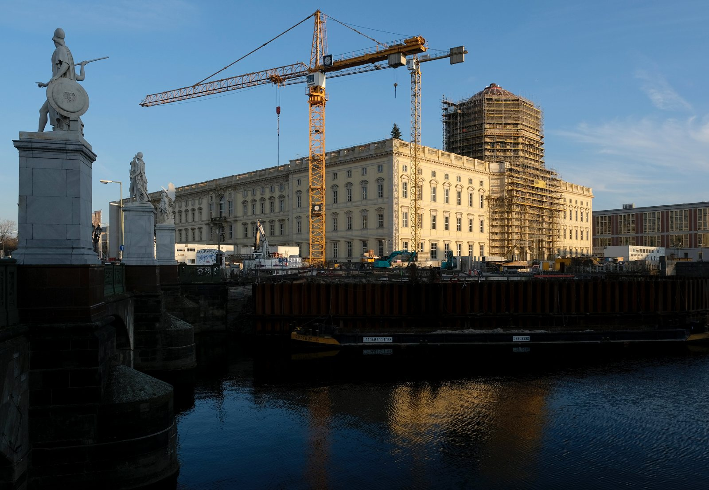
The reconstruction of the Berlin Palace, January 2020. The original palace—the Hohenzollerns’ main residence from 1701 to 1918—was damaged in World War II and demolished by the East German government. Its rebuilding after German reunification, David Motadel writes, is the result of ‘a new nostalgia for the country’s royal past and a neo-Prussian revival.’
There seem to be few serious supporters of the Hohenzollern claims. One of them is Benjamin Hasselhorn, a theologian and historian from Würzburg, who in the Neue Zürcher Zeitung denounced the 1994 law for making “potential property claims dependent on the political views and actions of the ancestors.” (He also wrote that the anti-Semitic statements of Wilhelm II, which he trivialized as “private comments,” had to be contextualized properly.) In the same newspaper, Hans-Christof Kraus, a historian at the University of Passau, repeated Clark’s thesis about Wilhelm’s political insignificance, claiming that after 1918 the Hohenzollerns’ reputation was in tatters.
As the public debate gained momentum last fall, Clark tried to qualify his conclusion in an interview with Der Spiegel: “I stand by what I wrote at the time. But in view of the course that the case has taken, it seems to be more important today to ask about the crown prince’s willingness to collaborate than about his actual influence on events.” He claimed that rather than assessing whether Wilhelm had supported the Nazis, he had assessed whether his support had been of any use to them. At the same time, he doubled down on his insistence that it had not:
The crown prince suffered from overconfidence bordering on the delusional. If one were to list Hitler’s most important supporters, he would not be among the first 300…. Many celebrities crowded around the Nazi leaders, including industrialists, bankers, church leaders and military leaders. Were the photographs featuring the crown prince more important to the regime than others? I doubt that.
It is uncontested that others in the establishment were equally or more implicated—but this does not lessen the significance of the prince’s support.
Anxious to control the public discussion of the case, the Hohenzollerns’ lawyer, Markus Hennig, has issued lawsuits against some of the major German newspapers that have reported on it, including the Frankfurter Allgemeine Zeitung, Der Spiegel, and Die Zeit. The family has also started an aggressive legal battle against historians who contested their version of history. The first was Malinowski, not because of his expert report but because he made public statements on various details connected with it, such as public access to the family archive and the question of whether the Hohenzollerns intended to manipulate their representation in a planned museum. Other historians facing legal action for expressing opinions on the debate include the Potsdam professors Martin Sabrow and Winfried Süß and the Princeton scholar Karina Urbach. In a recent open letter to Georg Friedrich Prinz von Preußen, Sabrow, the director of the Center for Contemporary History in Potsdam, warned that these actions posed a real “threat to freedom of scholarship.”
Many Germans are bewildered by their former royal family’s demands. “This country does not owe a single coffee cup to the next-born of a luckily long-vanquished undemocratic regime, let alone art treasures or real estate,” wrote Stefan Kuzmany, a columnist for Der Spiegel. “Even the request is an insult to the Republic.” The Hohenzollern wealth, he argued, was the product of historical injustice: “The aristocracy in general, [and] the Hohenzollerns in particular, have always been a plague on the country and the people. Like all so-called noblemen, they have snatched their fortune through the oppression of the population.” As Clark noted in his interview, “There seems to be a strong animus against the nobility within parts of the German public.”
Behind the controversy is the broader question of Germany’s monarchical legacy. After German reunification in 1990, the country’s political identity was renegotiated. Communist East Germany was in ruins, its socialist story shattered. But West Germany’s political narratives also seemed out of date. In this vacuum, older conservative versions of German nationhood began to reemerge. The reunited republic experienced a new nostalgia for the country’s royal past and a neo-Prussian revival. This resulted, for example, in major reconstruction projects, most notably (and controversially) the rebuilding of the Berlin Palace in the capital, the Potsdam City Palace, and the Garrison Church. In a grand ceremony, the remains of Friedrich the Great and his father, the “soldier king” Friedrich Wilhelm I, were solemnly transferred from Hohenzollern Castle in Baden-Württemberg to Potsdam. Books glorifying Prussia suddenly found a wide audience.
All this expressed a longing for a proud German past, no matter how imaginary, and a desire to reorient the republic’s official culture of memory away from the twelve years of Nazi barbarism. Some have observed these developments with concern, fearing the emergence of a new nationalism. As early as 1995, Jürgen Habermas, in his essay “1989 in the Shadow of 1945: On the Normality of a Future Berlin Republic,” powerfully warned that a new emphasis on more positive periods of German history—new “historical punctuations,” as he put it—would diminish the importance of the collapse of civilization in 1933–1945.
The German government had planned to settle the Hohenzollerns’ case through mediation behind closed doors. Unmoved by the heated public debate of the past months, Chancellor Angela Merkel’s conservative Christian Democratic Union—in contrast to its more reluctant Social Democratic coalition partner—seems determined to pursue a conciliatory course toward the former royal family. This became clear during a debate in the German parliament about the case earlier this year, when her party found itself agreeing with the far-right Alternative für Deutschland in supporting mediation. At the official hearing in the parliament’s cultural committee a few days later, on January 29, 2020, positions seemed to have further hardened. Whereas the Social Democrats, Greens, and Left Party called the Potsdam historian Stefanie Middendorf, Brandt, and Malinowski as historical expert witnesses, all of whom underlined once more the Hohenzollern family’s troubling historical record, the conservatives brought in Hasselhorn, who skillfully, though misleadingly, claimed that the case was highly contested among historians and that there was a lack of historical research on “Crown Prince” Wilhelm. It seems that Merkel’s party feels it would lose even more credibility if it were to change its course of the last decade. Another concern is that negotiations might lead to a better deal for the state than an unpredictable and protracted court case. Still, there is a chance that a German court will ultimately have to decide.
Postwar Germany, where the tragedies of the past are omnipresent, has experienced a series of major public historical controversies, among them the debate over Fritz Fischer’s claims in the 1960s that Germany was mainly responsible for the outbreak of World War I, the so-called Historikerstreit in the 1980s about whether the Nazis’ crimes were different in nature from those of the Soviet Union, and the argument in the 1990s over Daniel Jonah Goldhagen’s book about the responsibility of ordinary Germans for the Holocaust. These public renegotiations of the past tell us as much about contemporary German society as about history. The Hohenzollern controversy is not only about the long shadows cast by the Nazi period, but also about the place of the monarchical heritage in today’s democratic Germany.
—February 26, 2020

