DBQ Sports 2006

- Analyze how Europeans perceive the role of organized sports in Europe during the period from 1860 to 1940 ?

Document 1
Source: Sir Robert Baden-Powell, founder of the Boy Scouts, Scouting for Boys, London, 1908.
Football [soccer] in itself is a grand game for developing a lad physically and morally, for he learns to play with good temper and unselfishness, to play in his place and “play the game” and these are the best of training for any game of life. But it is a vicious game when it draws crowds of lads away from playing the game themselves to be merely onlookers at a few paid performers. There are thousands of boys and young men, pale, narrow-chested, hunched up, miserable specimens, smoking endless cigarettes, numbers of them betting, all of them learning to be hysterical as they groan and cheer in panic along with their neighbors.

Document 2
Source: Martin Berner, Berlin journalist, “The Olympic Idea in the World,” Soccer, Track and Field Journal, Berlin, 1913.
The Olympic Games are a war, a real war. You can be sure that many participants are willing to offer — without hesitation — several years of their lives for a victory of the fatherland. The Olympic idea of the modern era has given us a symbol of world war, which does not show its military character very openly, but — for those who can read sports statistics — it gives enough insight into world ranking.

Document 3
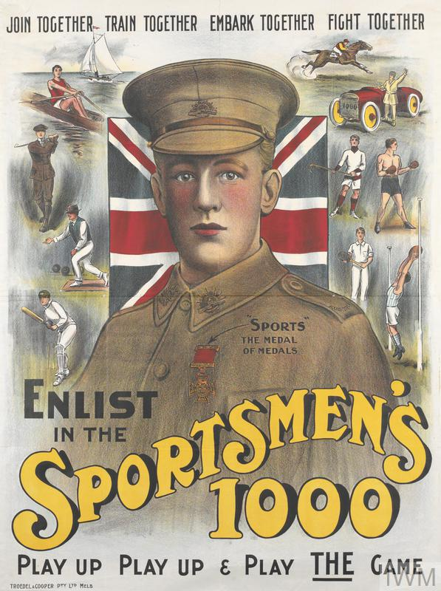
Source: British imperial government recruitment poster, First World War, 1914–1918.

Document 4
Source: Nikolai Semashko, physician and first Soviet Health Minister, “Tenth Anniversary of Soviet Medicine in Physical Education,” Theory and Practice of Physical Education, Moscow, 1928.
Physical culture in the Soviet understanding of the term is concerned not with record breaking, but with people’s physical health. It is an integral part of the cultural revolution and therefore has personal and social hygiene as its major objective, teaching people to use the forces of nature — the sun, air, and water — the best proletarian doctors.

Document 5
Source: Alice Profe, German physician, “Recent Observations regarding the Physical Education of Women,” Railroad Exercise and Sports Newspaper, Berlin, 1930.
There is no muscle which is built and works in a female fashion and which reacts in a special manner to the exertion of physical exercises; there is no female blood, no female breathing, which makes the female particularly suitable for swinging movements. None of these claims has a scientific basis. Just as women do not eat differently from men to gain strength, neither do they need different exercises from men to achieve a strengthening of their bodies.

