DBQ Elizabeth I 2011

- Analyze the influence of ideas about gender on the reign of Elizabeth I and explain
how Elizabeth responded to these ideas.

Document 1

Source: John Knox, Scottish religious reformer, First Blast of the Trumpet Against the
Monstrous Regiment of Women, 1558.

To promote a Woman to bear rule, superiority, dominion, or empire above any Realm,
Nation, or City, is against all Nature . . . it is the subversion of good order, of all equity
and justice. . . . And that the Holy Ghost does manifestly express, saying: “I suffer not a
woman to usurp authority above the man.” . . . So both by God’s law and the interpretation of the Holy Ghost, women are utterly forbidden to occupy the place of God in the offices aforesaid . . . .

Document 2

Source: Parliament of England, Act of Supremacy, 1559.

The queen’s highness is the only supreme governor* of this realm and of all other her
highness’s dominions and countries, as well in all spiritual or ecclesiastical things or
causes as temporal, and no foreign prince, person, prelate, state, or potentate hath or ought to have any jurisdiction, power, superiority, pre-eminence, or authority, ecclesiastical or spiritual, within this realm.

* The first Act of Supremacy in 1534 declared Henry VIII “Supreme Head” of the Church
of England.

Document 3

Source: The Second Book of Homilies, produced by bishops of the Church of England, authorized by Elizabeth I, 1562.

The husband ought to be the leader and author of love in cherishing and increasing
concord. . . . But as for wives, they must obey their husbands, and cease from
commanding, and perform subjection. For this surely doth nourish concord very much, when the wife is ready at hand at her husband’s commandment . . . .

Document 4
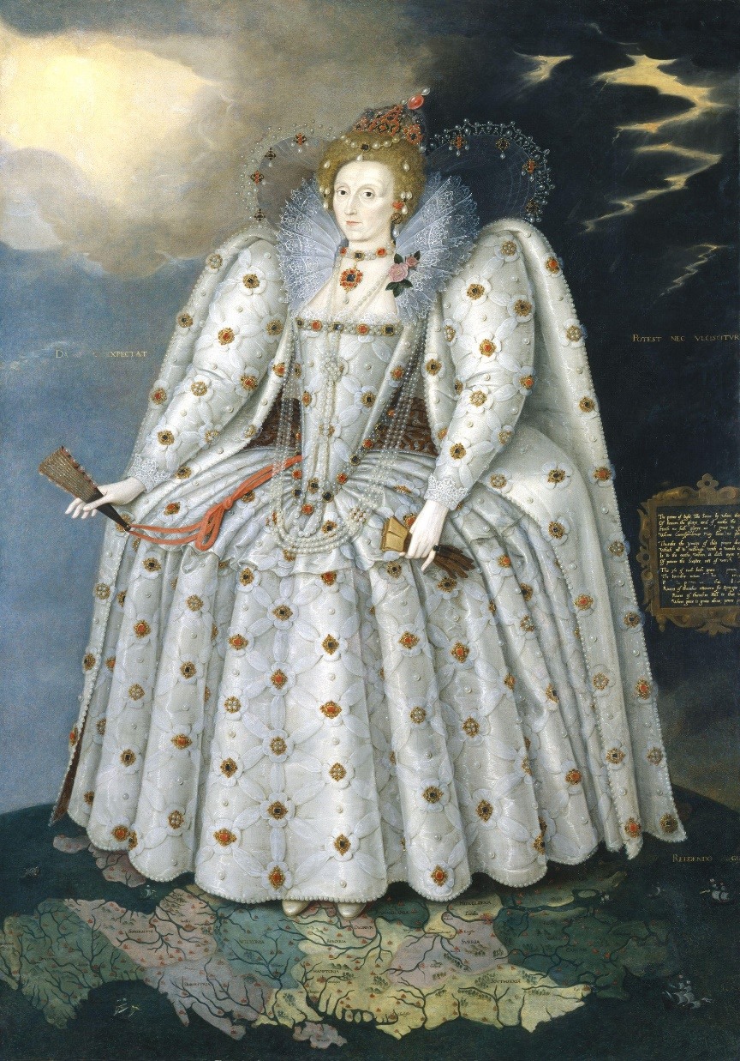
Source: Marcus Gheeraerts the Younger, English court painter, portrait of Elizabeth I
standing on a map of England, 1592.

Document 5

Source: William Tooker, Elizabeth’s personal chaplain, describing a “touching” ceremony,* 1597.

How often have I seen her most serene Majesty, prostrate on her knees, body and soul rapt in prayer . . . how often have I seen her withher exquisite hands, whiter than whitest snow, boldly and without disgust, pressing their sores and ulcers, and handling them to health . . . how often have I seen her worn with fatigue, as when in one single day, she healed eight and thirty persons of the struma.**

* The “royal touch” of English monarchs was believed to cure certain diseases, and
monarchs had historically performed “touching” ceremonies on people suffering from
these diseases.

** a disease of the skin

Document 6

Source: Elizabeth I, speech to Parliament delivered in 1559, recorded in an official history of her reign, first published in 1615.

But now (said she), that the public care of governing the kingdom is laid upon me, to draw upon me also the cares of marriage may seem a point of inconsiderate folly. Yea, to satisfy you, I have already joined myself in marriage to an husband, namely the Kingdom of England. And behold (said she), which I marvel ye have forgotten, the pledge of this my wedlock and marriage with my kingdom. (And
There with she drew the ring from her finger and showed it, wherewith at her coronation she had in a set form of words solemnly given herself in marriage to her kingdom.)

Document 7

Source: Elizabeth I, speech to English troops delivered in 1588, before the attempted
invasion of the Spanish Armada, recorded in a letter by an eyewitness, 1623.

I have placed my chiefest strength and safeguard in the loyal hearts and good will of my
subjects. And therefore I am come amongst you at this time, not as for my recreation or
sport, but being resolved, in the midst and heat of the battle, to live or die amongst you all: to lay down, for my God, and for my kingdom, and for my people, my honor and my blood, even the dust. I know I have but the bodyof a weak and feeble woman, but I have
the heart and stomach of a king, and of a king of England, too; and think foul scorn that
Parma or Spain, or any prince of Europe, should dare to invade the borders of my realms: to which, rather than any dishonor should grow by me, I myself will take up arms. I myself will be your general, judge, and rewarder of every one of your virtues in the field.

