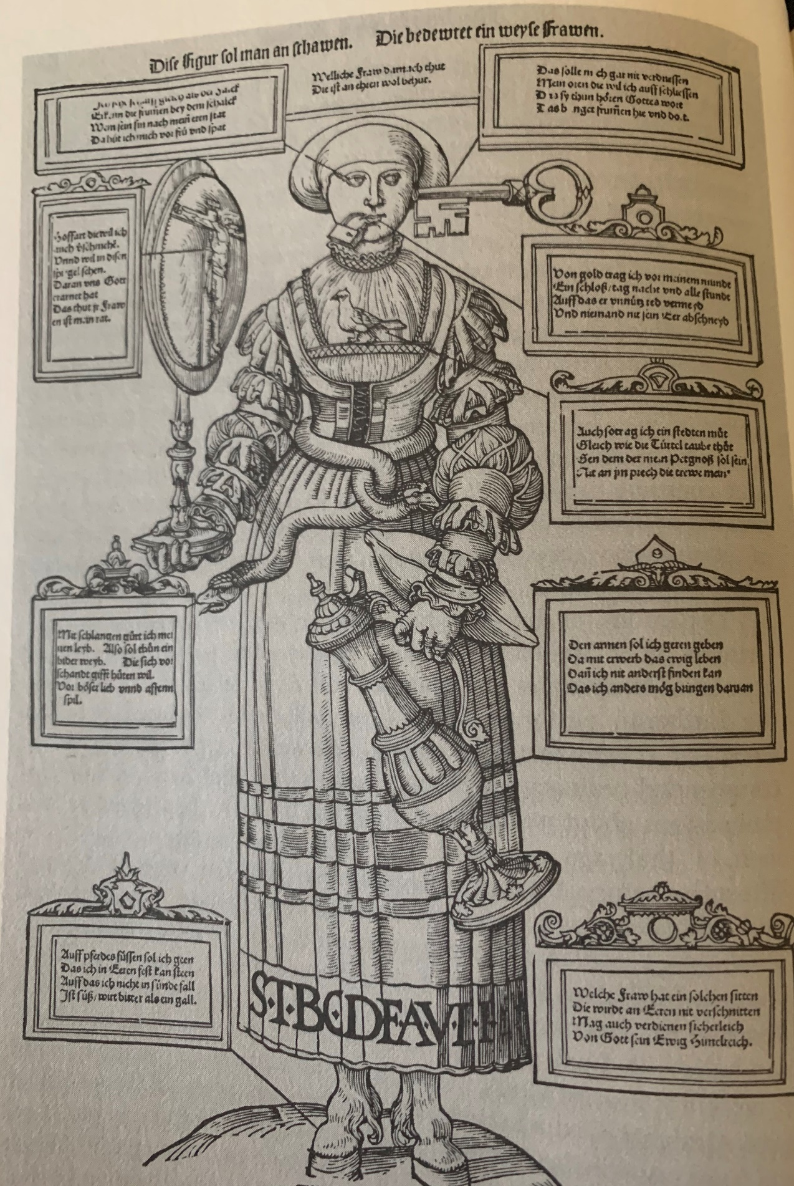
A Wise Woman
16th Century Catholic portrayal of good wife
- Ozment, Steven. When Fathers Ruled: Family Life in Reformation Europe, Harvard University Press 1983. 66-67

Look at this figure, which signifies a wise woman;
any woman who does as she instructs
protects her honor well.

(Eyes) (Waist)
I see keenly as the hawk My waist is girded, with serpents,
And discern the honest from the false. As should that of every honest woman
I guard myself both day and night Who wants protection from the poison
From one who against my honor plots. of scandal.
From evil love, and shameful play.
(Ears)
I shall not be discouraged (Left hand)
From opening my ears I shall serve the aged freely
So that they can hear God’s word, And thereby gain eternal life.
Which keeps the pious on their guard. No other thing that I can do
Will bring this end about.
(Right hand)
I will despise pride (Feet)
And behold myself in the mirror of I shall go about on horses’ hoofs
Christ, And be steadfast in honor.
Through whom God has redeemed us. And not fall into sin,
Which, while sweet at first, turns bitter
(Mouth) as gall.
Every hour, day and night,
I wear a golden lock upon my lips Any woman who has such traits
So that they say no harmful words Will maintain her honor undiminished
Or wound another’s honor. And surely earn from God above
An eternal kingdom in heaven.
(Breast)
Like the turtle dove,
I have a steadfast heart,
Faithful to him who will be my
husband.
No fault of his will break my loyalty.

