Analyze the short-term and long-term factors that led to the Second World War

Document 1
Source: John Maynard Keynes, The Economic Consequences of the Peace, 1919
The nature of the contract between Germany and the Allies resulting from this exchange of documents is plain and unequivocal. The terms of the peace are to be in accordance with the addresses of the President, and the purpose of the peace conference is ‘to discuss the details of their application.’ The circumstances of the contract were of an unusually solemn and binding character; for one of the conditions of it was that Germany should agree to armistice terms which were to be such as would leave her helpless. Germany having rendered herself helpless in reliance on the contract, the honour of the Allies was peculiarly involved in fulfilling their part and, if there were ambiguities, in not using their position to take advantage of them.”

Document 2
Source: Leonard Raven-Hill, Punch Magazine (a British magazine of humor and satire), December 10, 1919
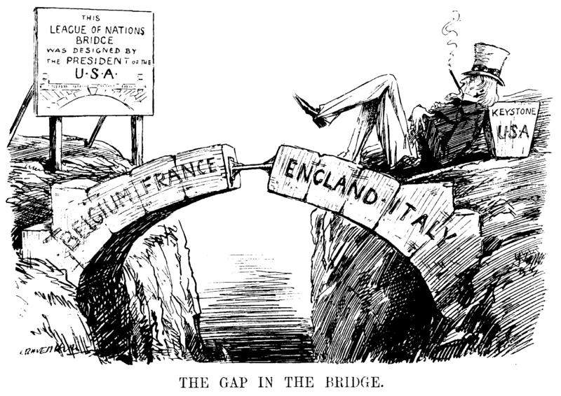

Document 3
Source: Adolf Hitler, Mein Kampf, 1923
Much as all of us today recognize the necessity of a reckoning with France, it would remain ineffectual in the long run if it represented the whole of our aim in foreign policy. It can and will achieve meaning only if it offers the rear cover for an enlargement of our people's lebensraum [living space] in Europe. For it is not in colonial acquisitions that we must see the solution of this problem, but exclusively in the acquisition of a territory for settlement, which will enhance the area of the mother country, and hence not only keep the new settlers in the most intimate community with the land of their origin, but secure for the total area those advantages which lie in its unified magnitude.

Document 4
Change in Economic Indicators, 1929-1932
 | United States | Great Britain | France | Germany
Industrial Production | -46% | -23% | -24% | -41%
Wholesale Prices | -32% | -33% | -34% | -29%
Foreign Trade | -70% | -60% | -54% | -61%
Unemployment | +607% | +129% | +214% | +232%

Document 5
Source: Joachim von Ribbentrop, German Ambassador to Rome, 1937

The good German-Italian relations prevailing at present are based on some elements that seem to guarantee durability but also on others of a transitory nature. The former derive primarily from the geographical situation, from many conditions of life shared in common and…also from the kinship of the two domestic political systems…The elements of a transitory nature spring from the political situation of the day, as for instance from the close collaboration in the Spanish conflict.

Document 6
Source: Neville Chamberlain, British Prime Minister, speech to Parliament, September 27, 1938
However much we may sympathize with a small nation confronted by a big and powerful neighbor, we cannot in all circumstances undertake to involve the whole British Empire in war simply on her account. If we have to fight it must be on larger issues than that. I am myself a man of peace to the depths of my soul. Armed conflict between nations is a nightmare to me; but if I were convinced that any nation had made up its mind to dominate the world by fear of its force, I should feel that it must be resisted. Under such a domination life for people who believe in liberty would not be worth living; but war is a fearful thing, and we must be very clear, before we embark upon it, that it is really the great issues that are at stake, and that the call to risk everything in their defense, when all the consequences are weighed, is irresistible.
For the present I ask you to await as calmly as you can the events of the next few days. As long as war has not begun, there is always hope that it may be prevented, and you know that I am going to work for peace to the last moment. Good night. . . .

Document 7
Source: German-Soviet Non-Aggression Pact, August 23, 1939
The Government of the German Reich and the Government of the Union of Soviet Socialist Republics desirous of strengthening the cause of peace between Germany and the U.S.S.R and proceeding from the fundamental provisions of the Neutrality Agreement concluded in April 1926 between Germany and the U.S.S.R., have reached the following agreement:

ARTICLE I
Both High Contracting Parties obligate, themselves to desist from any act of violence, any aggressive action, and any attack on each other, either individually or jointly with other powers.

ARTICLE II
Should one of the High Contracting Parties become the object of belligerent action by a third power, the other High Contracting Party shall in no manner lend its support to this third power.

ARTICLE III
The Governments of the two High Contracting Parties shall in the future maintain continual contact with one another for the purpose of consultation in order to exchange information on problems affecting their common interests.

ARTICLE IV
Neither of the two High Contracting Parties shall participate in any grouping of powers whatsoever that is directly or indirectly aimed at the other party.

ARTICLE V
Should disputes or conflicts arise between the High Contracting Parties over problems of one kind or another, both parties shall settle these disputes or conflicts exclusively through friendly exchange of opinion or, if necessary, through the establishment of arbitration commissions.

ARTICLE VI
The present treaty is concluded for a period of ten years, with the provision that, in so far as one of the High Contracting Parties does not denounce it one year prior to the expiration of this period, the validity of this treaty shall automatically be extended for another five years

