Practice AP Exams

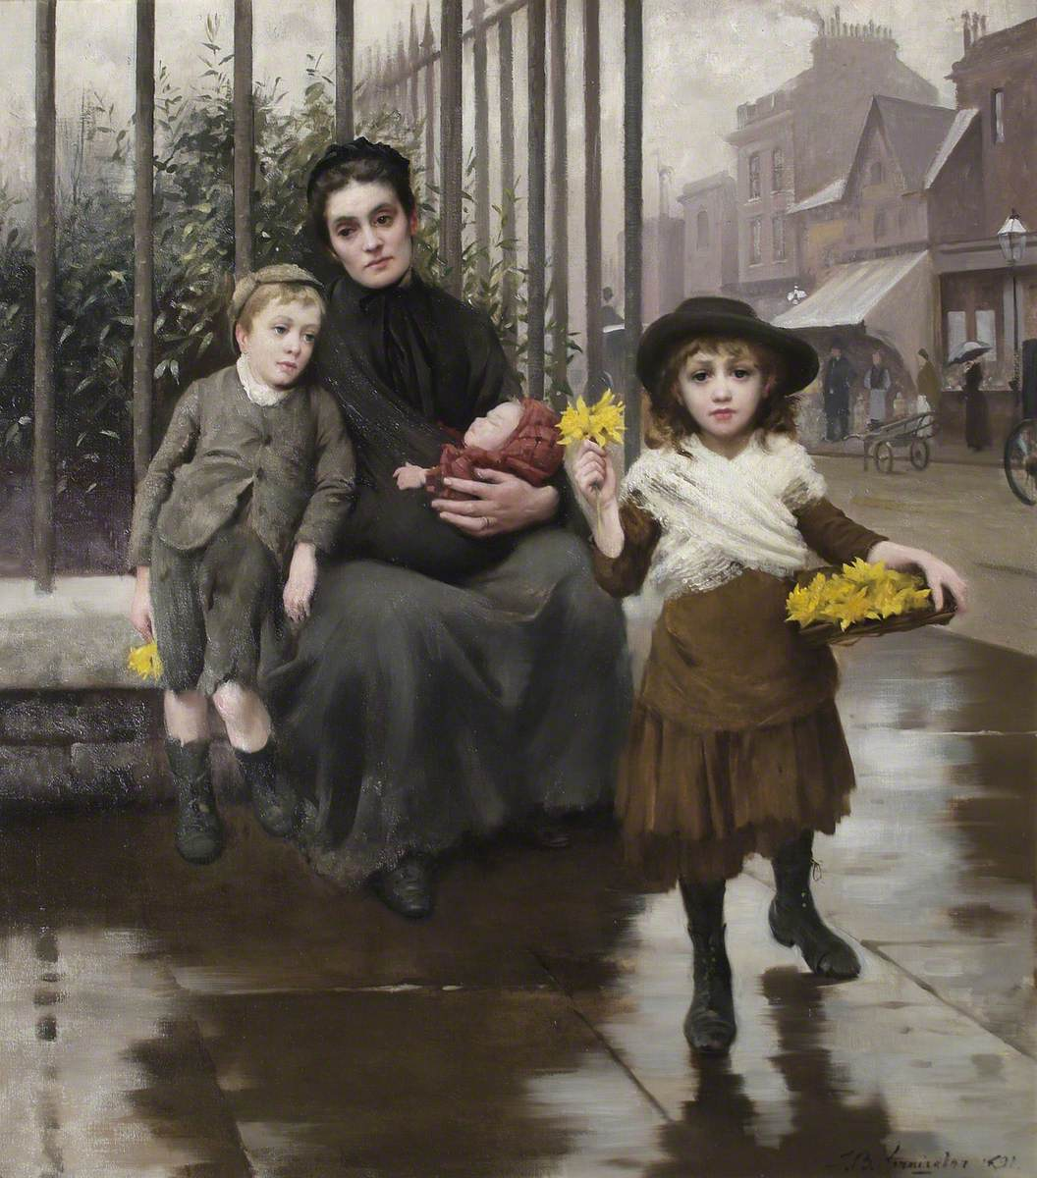
Thomas Benjamin Kennington, English Artist, The Pinch of Poverty, 1891
- A) Describe the attitude toward poverty expressed in this painting.
B) Describe a broader context in which this painting was produced.
C) Explain one way in which reformers in the late 1800’s and early 1900s attempted to address the problems of poverty in Europe.

Student Answers

- A) The painting expresses a sympathetic view towards the impoverished . It shows the family in their dire circumstances but in a way that shows pity rather than disgust.
B) This painting was produced during a period of high urban poverty throughout most of Europe as well as during the increase of support of reform.
C) One way reformers during the late 1800s attempted to address the problems of poverty was through the creation of social welfare programs. Bismarck as well as other leaders in the late 1800s started a series of reforms such as disability insurance to prevent insured working from going into poverty.

Grade:

- The attitude toward poverty expressed in this painting is depressing and sad. This is a good way to describe it because this mother has two children to feed and take care of as well as herself. This painting was produced because many families suffered from poverty in this time period. Mothers and fathers tried their best to find jobs so they could take care of their families. One way in which reformers during the late 1800s and early 1900s attempted to address the problems of poverty in Europe was the industrial revolution. Industries across Europe opened allowing for job opportunities for families in need of them. The pay wasn’t great but he did help families a little bit to gain money for their families.
Grade

2. A) Describe ONE significant cultural or intellectual change during the Renaissance.
B) Explain ONE cause of cultural or intellectual change during the Renaissance.
C) Describe a significant difference between the art of the Italian Renaissance and the art of the Protestant Reformation
Student Answers:
- A) One significant intellectual change during the Renaissance is the shift to the classics of ancient Greece and Rome. The Renaissance changed the intellectual scene away from theology to a study of classical art as portrayed in Pico Dello Mirandola “Platonic Academy.” These ideals would create the perfect Renaissance person, through the classics, not religion.
B) One cause of the intellectual change to the classics is Petrarch. Petrarch was the first to start the study of the classics as humanism. These changes are shown by his title Father of Humanism. Petrarch began the path for the Renaissance study of the classics by shifting away from religion.
C) A significant difference in art of the Renaissance and the Protestant Reformation is the focus. In Renaissance art, focus is on classical ideals, like the gods and goddesses, while the Protestant Reformation found the glorification of God and biblical stories. An example of this is the “School of Athens”, which had a focus on Plato and Aristotle, showing the Renaissance focus on the classics.

Grade:

- A) The Renaissance was a period of significant cultural and intellectual change. Many people began to shift their focus and ideologies towards more classic Greek and Roman literature and politics, and it began to shift to secularism. Rather than view the world with regards to religion and God in every second of the day, people began to think in a more secular, rational way.
B) Many of the cultural and intellectual changes during the Renaissance were caused in part by the printing press. Before, literary works had to be written and copied by hand, but with the introduction of the printing press, these works could now be mass produced and spread much faster, vernacular languages too.
C) The art of the Italian Renaissance and of the Protestant Reformation differed in that Italian Renaissance art was more focused on the details of the natural world, whereas art of the Protestant Reformation focused more on humanism and human beings.

Grade

3. “The Revolutionary Period of England may be said to have lasted nearly 50 years, if we reckon from the beginning of the civil wars under Charles I to the ascension of William III in 1688. The efforts of these 50 years had no other real and permanent object than the establishment of the current constitution, which is the finest monument of justice and moral greatness existing in Europe. The same movement in the minds of men that brough about the revolution in England was the cause of that of France in 1789. Both belong to a new era in the progress of social order – the establishment of representative government – a point toward which humanity is directing itself.”
Anne Louise Germaine de Stael, author and historian, Considerations on the Principal Events of the French Revolution, 1818
- Describe one argument the author makes regarding the revolutions discussed in the passage.
- Identify one piece of evidence not found in the source that would support the author’s claim regarding representative government.
- Explain one limitation of de Stael’s view on the French Revolution.

Student Responses
- A) Regarding the revolutions discussed in the passage, the author argues that England’s 50 year revolution led to the adoption of the current constitution and that it is the finest monument of justice and moral greatness existing in Europe.
B) From the way that the author is speaking so highly of England’s current constitution, deeming it the finest monument of moral greatness existing in Europe. I can assume that she strongly favors representative governments, the English one in particular.
C) The author also believes that the French Revolution was progressive and a step in the right direction, however, I don’t feel she is a French citizen therefore she will never fully understand the French Revolution and her view is limited

Grade

- A) The author argues that the French and British Revolutions allowed for a period of social progress. This can be seen through the breaking down of the Estate system in France, because this system was oppressing the third estate through the payment of taxes and lack of representation. Therefore, this breaking down of the Estate system allowed for a period of social progress, in regards to equality amongst men, expansion of natural rights, and representation in the government.
B) The Thirty Years War supports the argument of revolutions and representative government allows for social progress. The Thirty Years War was fought as a result of the ideas that sparked during the Protestant revolution and a lack of religious toleration. Therefore, once the conflict was resolved the HRE was broken down into smaller estates that could decide their own religion, this is significant because it advanced the idea of religious toleration within Europe and sparked widespread social movements.
C) De Stael’s view of the French Revolution is hindered through Napoleon’s rise to power, Napoleon reversed the social progress made during this period by limiting freedom of speech and press, thus rendering the events of the French Revolution particularly useless. This is significant because Napoleon’s rise completely contradicted the absolute power that was fought against.

Grade:

LEQ Examples

- Evaluate the most significant cultural effect of the First World War during the period of 1918 to 1939.

- Before WWI there was the German unification led by Bismarck of Prussia, he made Prussia and Germany come together as one to be a stronger nation, because their countries had similar cultures. Bismarck then got South Germany to also join Germany by starting the Franco-Prussian War, bringing them closer together with their victory. Before WWI countries were competing in the industrial revolution and on the eve of WWI countries people were very nationalist and encouraged the war because they thought it was going to be a short war, like most wars in the past. The most significant cultural changes after WWI was an overall sadness and anger in some countries. In many countries they went through this thought of existentialism which basically means people thought life had no meaning. Which makes a lot of sense because so many families had lost their sons, brothers, and fathers in a pointless war of countries showing off new technology. Other countries like Germany and Italy were mad. Italy was angry because the allies promised Italy that they would give them land if they fought with the allies. At the Treaty of Versaille Italy was left out of most of the decision making and didn’t get any land. Germany was mad because they thought they could have won the war, but the government gave up on them. Another huge reason Germany was mad was because the Treaty of Versaille was extremely harsh on them. The French were very mad at Germany because most of the fighting was on French soil, so the French demanded Germany pay all the civil damages done in WWI and the Rhineland as a buffer zone between France and Germany. Germany quickly went bankrupt because the war had cost them so much along with paying the war reparations. To solve this Germany started to print money, but this didn’t work, it just caused hyperinflation. All of these problems in Germany piled up. Angry war veterans and anti-semites started joining this radical political party called the Nazis, led by Adolf Hitler, and they saw him as Germany’s new hope to go back to the old powerful German state. Hitler used the Treaty of Versaille and Jewish hatred to fuel the German people’s anger, once he toned down the radicalism and focused more on defeating communism in Germany, he gained the support of the middle class and was able to become the Chancellor of Germany. In conclusion, the negative culture impact of WWI was great. The two most significant effects were existentialism, an overall sadness and meaningless esistence felt by many people in Europe. The other huge impact of WWI was the anger towards the loss of WWI from the conditions of the Treaty of Versaille, that led to the rise of the Nazis in Germany causing WWII.

